CSA1006 SOFTWARE ENGINEERING
NAME: RAHIMA BANU N SLOT:B
REG NO:192525009 FACULTY NAME: Dr R SURENDRAN
Assignment Title: Case Study Analysis

QuietPath: A Noise-Aware Navigation System for Comfortable and Healthy Urban Travel

1. Understand the Problem Statement

1.1 Problem Statement
Modern navigation applications such as Google Maps, Apple Maps, and Waze primarily recommend routes based on the shortest distance or fastest travel time. Although these applications are highly effective for navigation, they do not consider environmental factors such as noise pollution. In urban areas, roads with heavy traffic, construction activities, crowded public spaces, and commercial zones often expose pedestrians and cyclists to excessive noise. Continuous exposure to high noise levels can cause stress, reduced concentration, headaches, sleep disturbances, and long-term health issues.
Certain groups of people, including students, elderly individuals, remote workers, tourists, patients, and people with sensory sensitivities, may prefer quieter routes even if the travel time is slightly longer. However, there is currently no widely available navigation system that allows users to select routes based on surrounding noise levels. This creates the need for a software solution that considers both travel efficiency and environmental comfort.

1.2 Objectives of the Proposed System
The main objective of QuietPath is to develop a software application that provides users with navigation routes based on noise levels in addition to distance and travel time.
The specific objectives are:
- To identify quieter walking and cycling routes.
- To estimate noise levels using traffic data, historical patterns, and user reports.
- To provide multiple route options based on user preference.
- To improve travel comfort and promote healthier urban mobility.
- To encourage environmentally conscious navigation.

1.3 Scope of the Problem
The proposed system is designed primarily for pedestrians and cyclists travelling within urban environments. It supports route planning by analyzing traffic conditions, public noise information, construction updates, and community-reported noise levels. The system focuses on route recommendation and does not replace existing navigation applications but complements them by introducing environmental awareness into route selection.

2. Identify Key Stakeholders and Challenges

2.1 Stakeholders
The proposed system involves several stakeholders who interact with the application in different ways.

Users
The primary users include pedestrians, cyclists, students, tourists, elderly citizens, office workers, and individuals with sensory sensitivities. They use the application to identify quieter routes that provide a more comfortable travelling experience.

Local Government Authorities
Municipal corporations and city planning authorities can use the collected noise information to identify areas with excessive noise pollution and plan infrastructure improvements.

Environmental Organizations
Organizations working on environmental protection and urban sustainability can analyze noise trends generated by the application to support awareness campaigns and policy recommendations.

Software Development Team
Developers, testers, UI/UX designers, database administrators, and project managers are responsible for designing, implementing, testing, and maintaining the software.

System Administrator
The administrator manages user accounts, maintains databases, monitors system performance, and ensures data security.

2.2 Challenges Faced by Stakeholders
Users often have no information regarding the noise levels of different routes before starting their journey. Local authorities struggle to collect accurate noise pollution data across large urban areas. Environmental agencies require reliable data to evaluate pollution levels. Software developers face the challenge of integrating multiple data sources while ensuring accurate route recommendations and system performance.

3. Analyze the Current Approach

3.1 Existing System
Most navigation systems today optimize routes based on travel time, shortest distance, or traffic congestion. Applications such as Google Maps provide real-time traffic updates and alternative routes but do not consider environmental comfort factors such as surrounding noise levels.

3.2 Strengths of the Existing System
The current navigation systems provide accurate GPS navigation, real-time traffic updates, estimated arrival times, and multiple route suggestions. They are widely accessible and easy to use.

3.3 Limitations of the Existing System
Despite their advantages, existing systems ignore the effects of environmental noise on users. They cannot identify quieter roads, provide noise information, or allow users to prioritize peaceful routes over the fastest routes. Users with specific health or comfort requirements therefore receive limited assistance.

3.4 Problems to be Addressed
The major gaps identified are:
- Absence of noise-based route selection.
- No visualization of urban noise levels.
- Lack of community-based noise reporting.
- Limited personalization based on user comfort preferences.

4. Proposed Software Solution

4.1 Proposed Solution
QuietPath is proposed as a web and mobile application that integrates digital maps, traffic information, public noise datasets, and community reports to recommend routes based on environmental noise levels.
Unlike conventional navigation systems, QuietPath calculates a Noise Score for every road segment. When a user enters a destination, the software generates three route options:
- Fastest Route
- Quietest Route
- Balanced Route
The system also displays a Noise Heat Map, enabling users to visualize noisy and peaceful areas before selecting a route.

4.2 Functional Modules

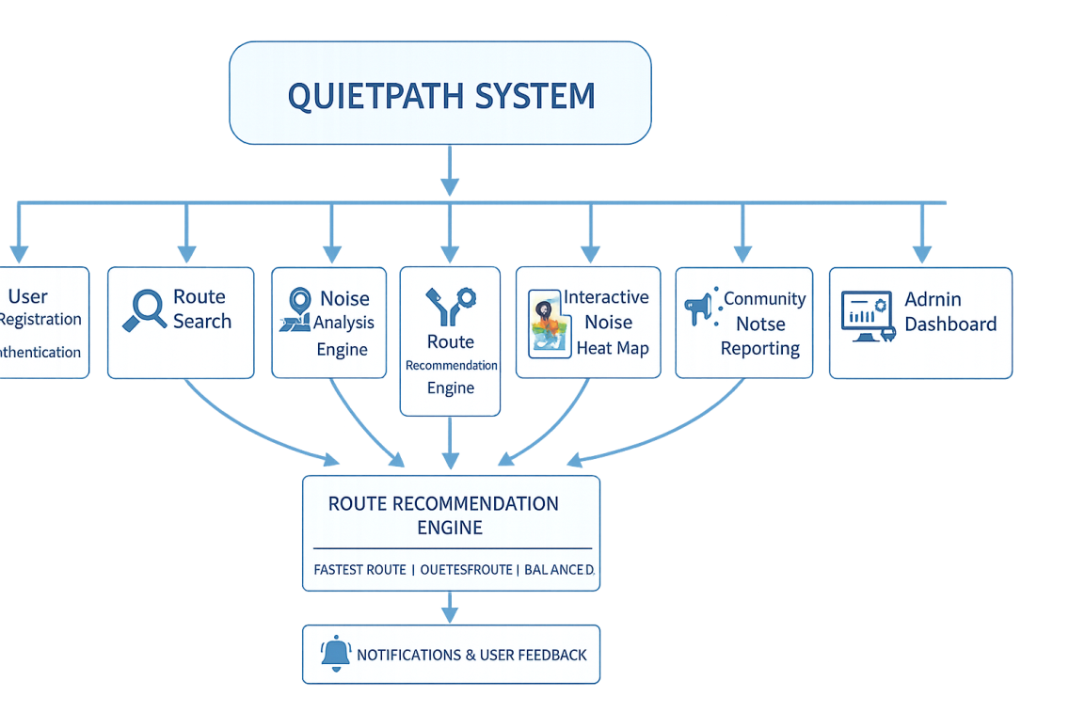

Module 1 – User Registration and Authentication
Users create secure accounts, log in, and manage their profiles.

Module 2 – Route Search
Allows users to enter source and destination locations and search for available routes.

Module 3 – Noise Analysis Engine
Processes traffic data, historical information, public datasets, and user reports to estimate road noise levels.

Module 4 – Route Recommendation Engine
Generates and ranks routes according to user preferences, such as fastest, quietest, or balanced.

Module 5 – Interactive Noise Map
Displays colour-coded maps representing different levels of urban noise.

Module 6 – Community Reporting
Users can report temporary noise sources such as construction activities, traffic jams, or public events.

Module 7 – Notification System
Alerts users about unusually noisy roads, road closures, or newly reported disturbances.

Module 8 – Administration Dashboard
Allows administrators to manage reports, monitor system performance, and maintain the database.
WORKFLOW:
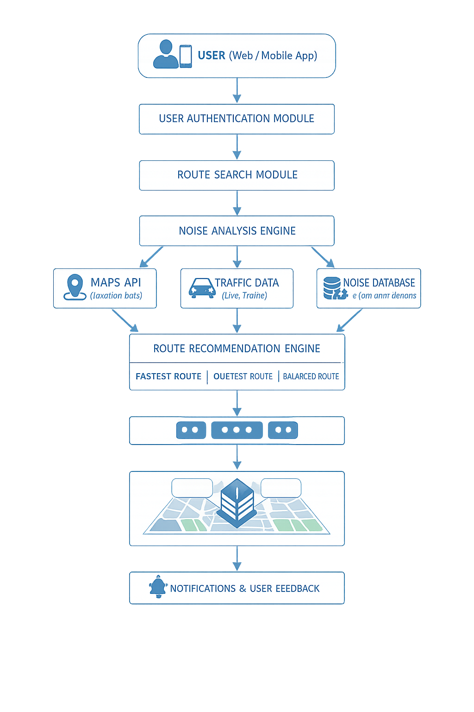

4.3 Functional Requirements
- User registration and login.
- Search routes between locations.
- Display multiple route options.
- Calculate and display noise scores.
- Generate interactive noise maps.
- Allow community noise reporting.
- Send alerts and notifications.
- Maintain user profiles.

4.4 Non-Functional Requirements
Performance: Route recommendations should be generated within a few seconds.
Scalability: The software should support increasing numbers of users and additional cities.
Security: User information must be protected through authentication and encrypted communication.
Reliability: The application should provide consistent route recommendations and high system availability.
Maintainability: Modular architecture should simplify future updates.
Usability: The interface should be intuitive and accessible to users of all age groups.

4.5 Application of Software Engineering Principles
The proposed software follows software engineering principles by dividing the system into independent modules such as user management, routing, noise analysis, reporting, and notifications, thereby improving modularity and maintainability. Scalability is achieved through cloud deployment and API integration. Reliability is ensured through proper testing and validation of routing algorithms. Security measures include secure authentication, encrypted communication, and controlled user access. Usability is enhanced by providing a simple interface with clear navigation and interactive maps.

5. Justification of the Chosen SDLC Model

Agile Scrum Methodology
The Agile Scrum methodology is selected because the project requirements may evolve as user feedback is received. Route recommendation algorithms, user interface improvements, and additional environmental factors can be added incrementally through short development iterations.
Agile supports continuous customer feedback, frequent testing, faster delivery of working software, easier maintenance, and improved collaboration among developers. These characteristics make Agile an appropriate choice for developing QuietPath.

6. Expected Outcomes and Limitations

Expected Outcomes
The proposed software is expected to improve the quality of urban travel by allowing users to choose routes that minimize noise exposure. It promotes healthier commuting habits, improves user comfort, and contributes to environmental awareness. The application may also provide valuable urban noise data that can support government planning and environmental research.

Addressing the Identified Challenges
QuietPath addresses existing limitations by introducing noise-aware navigation, community reporting, and environmental visualization. These features enable users to make informed travel decisions rather than relying solely on travel time and distance.

Risks and Limitations
The system depends on the availability and accuracy of traffic and environmental data. Community-generated reports may occasionally contain inaccurate information. Initial deployment may require integration with mapping services and public datasets. Maintaining up-to-date noise information may also present operational challenges.

Future Enhancements
Future versions of QuietPath may integrate IoT-based noise sensors, artificial intelligence for predictive noise analysis, smartwatch support, voice-assisted navigation, and machine learning algorithms that learn user preferences and recommend increasingly personalized routes.

Conclusion
QuietPath is an innovative software solution that extends traditional navigation by incorporating environmental comfort into route planning. By considering urban noise levels alongside travel time and distance, the system enables users to make healthier and more informed travel decisions. The proposed solution follows key software engineering principles such as modularity, scalability, reliability, maintainability, usability, and security, making it both technically feasible and practically valuable. The Agile Scrum methodology further supports incremental development and continuous improvement, ensuring that the system can evolve to meet future user needs and technological advancements.

Criteria | Excellent (4 Marks) | Good (3 Marks) | Satisfactory (2 Marks)
Problem Understanding | Clearly explains the problem, objectives, and scope with complete understanding. | Explains the problem with minor omissions. | Basic understanding with limited explanation.
Stakeholder & Challenge Analysis | Identifies all stakeholders, their roles, and challenges with clear analysis. | Identifies most stakeholders and challenges with adequate analysis. | Identifies only a few stakeholders or challenges.
Current System Analysis | Thoroughly analyzes the existing system, strengths, weaknesses, and identifies all gaps. | Good analysis with most strengths and weaknesses identified. | Limited analysis with partial identification of issues.
Proposed Software Solution & Software Engineering Principles | Proposes an innovative, feasible solution applying appropriate software engineering principles (modularity, scalability, maintainability, security, etc.). | Suitable solution with good application of software engineering principles. | Basic solution with limited application of software engineering principles.
Methodology/Framework Justification | Selects the most suitable SDLC/model/framework and provides strong technical justification. | Suitable methodology selected with adequate justification. | Methodology selected but justification is weak.
Expected Outcomes & Limitations | Clearly explains expected outcomes, benefits, limitations, and future improvements. | Explains outcomes and limitations with minor omissions. | Limited discussion of outcomes or limitations.

